**Shatrughna**

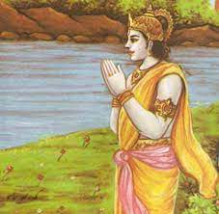

**BIRTH:**

Shatrughna and Laxman were sons of the second queen Sumitra, wife of Dashratha, the King of Ayodhya. Shatrughna mirrored many aspects of Lakshmana's personality and character.Lakshman followed the footsteps of the paragon of truth, Rama while Shatrughna was equally attached to the unworldly and devoted Bharat, son of Kaikey, and followed him everywhere for he knew that Bharat was a complete devotee of Rama. In Bharat's life, there was no other goal loftier than service to his brother.  
  
During the Sita Swayamvar, when Sita was wedded to Rama, Raja Janak arranged for the wedding of Shatrughna to Shrutkirti, the daughter of his brother Kushadhvaja. Bharat was married to Mandavi and Urmila to Lakshman.  
**RAMA'S EXILE:**  
  
Shatrughna asks Bharata why even Lakshmana could not prevent Dasaratha from sending Rama to the forest. Meanwhile, when Manthara arrives at the scen, Shatrughna seizes her with his powerful hand, threatens to punish her and abuses Kaikeyi too. When Kaikeyi pleads for mercy with her son, Bharata intervenses and Shatrughna releases Manthara. (Valmiki Ramayana Ayodhya Kanda, Chapter 78).  
  
  
When Bharat placed Rama's charan paduka (sandals), on the throne and went to live in far a away Nandigrama in a straw hut, he lived there for fourteen years, awaiting the arrival of Shri Rama. It was Shatrughna who assumed the mantle of royal duties and the running of the Kingdom.

**RULING THE KINGDOM:**  
For fourteen years he ruled, like an alert soldier and administrator. He made sure that the Queen mothers did not feel the absence of their sons. His guru had justly named him (as Shatrugna) for he very ably overpowered all evil forces and enemies of the state and the subjects.  
  
  
After fourteen years, Rama Lakshman and Sita returned to Ayodhya. Guru Vashistha arranged for the coronation of Rama. In those days, Daityas Madhu's son Lavanasura was creating havoc in Madhuvan (forest called Madhu), making the subjects very unhappy. Shatrughna then told Rama, that the world knew the many ways in which Lakshman had served Him. Shatrughna requested Rama to give Shatrughna a chance to prove his Kshatriya (warrior caste) value by killing Lavanasura and serving Ayodhya.. Rama gave him the permission. Shatrughna killed Lavanasura and established the kingdom of Madhupur, which later came to be known as Mathura. Raja Rama made Shatrughna the king of Madhupur.  
  
**DIG VIJAY:**  
When Rama conducted the Ashwamegh Yagna (horse sacrifice where a horse is let loose and whichever kingdom that horse crosses into has to accept the owner of the horse as their lord or then fight with them), it was Shatrughna who leaded the horse Dig Vijay and made the yagna successful. Shatrughna was also a part incarnation of Vishnu.  
  
  
By looking after the welfare of the family, the queens, the subjects and the kingdom, Shatrughna gave a stellar proof of his ideal character. He is equal to Bharat and Rama in his goodness and nobility.

**Indrajit**

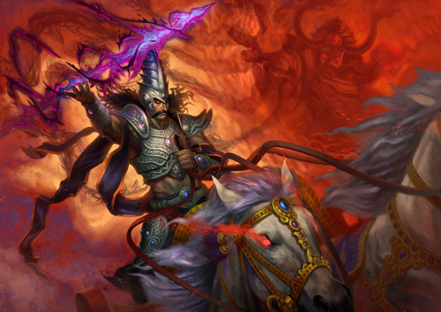

**ORIGIN:**

Indrajit, also known as Meghanad, was a prince of Lanka. He has been mentioned in the Indian epic Ramayana as the son of king Ravana who wanted him to be an ardent devotee of Lord Shiva. Indrajit played an active role in the battle between Lord Rama and Ravana. He was a mighty warrior. He is the only warrior along with Lord Parashurama who possessed the three weapons of Trimurti, i.e. Brahmanda Astra, Vaishnava Astra, and Pashupatastra. He received all kinds of celestial weapons from his mentors Shukra, Lord Brahma, Lord Vishnu and Lord Shiva. After defeating the deities, he took their arms and became the possessor of divine weapons of gods, demons, and Trimurti. He even twice defeated Lord Ram and Lakshman.

**FAMILY:**

Meghnad was the eldest son of Ravana and Mandodari. He was named Meghanad after his birth because his birth cry sounded like thunder. During his birth, Ravana wished his son to be supreme so that no one could defeat him. Ravana wanted him to be an excellent and knowledgeable warrior. Ravana knew a priest, and as per his instructions, Ravana commanded the planets and constellations in such a position that would allow Meghnad to be born the way he wanted. All the planets and constellation feared Ravana. Hence, the planets followed the instructions of Raavan during Meghnad’s birth. The planets aligned in such a manner that they fall in the 11th house of Meghnad’s horoscope. However, Shani had disobeyed Ravana's orders and had settled in the 12th house of Meghnad's horoscope. Ravana became furious at this. Due to the state of Shani, Meghanad had to die at the hands of Lakshman. At a very young age, Meghanad became the possessor of several supreme celestial weapons, under the guidance of Shukra, the guru of the demons. Since his childhood, Meghanad showed signs of becoming the great warrior. He went through tough penance to attain the knowledge of celestial weapons as well as magical powers and the art of sorcery. Meghnad was married to Sulochana, the daughter of the Serpent King Shesha Naga.

**BATTLES:**

During a battle between the deities and Ravana, Indra captured Ravana. To rescue his father, Meghanad attacked Indra and defeated all the Devas including Indra. Meghanad tied and mounted Indra onto his celestial chariot and dragged him to Ravana in Lanka. Ravana and Meghanad decided to kill Indra. But Lord Brahma intervened and asked Meghanad to free Indra. Lord Brahma was highly impressed by Meghnad's valour, and it was he who gave him the name Indrajit ("the conqueror of Indra"). Meghanad obliged and was granted a chance to claim for a boon from Brahma. Meghanada asked for immortality, but Brahma refused it saying that an absolute immortality is against the law of nature. He was granted another boon that after the completion of the Yajna of his native goddess Prathyangira or the "Nikumbhila yajna," he will get a celestial chariot, mounting on which, he will win over any enemy in the war and become invulnerable. But Brahma also cautioned him that whosoever would destroy this yajna would also kill him. It was due to these boons that Meghanad (Indrajit) got killed by Lakshman in war.

**Lakshman**

Brother from another mother. This saying best suits the case of Ram and Lakshman. The two brothers were like two bodies and one soul. And hence, even today, devotees take their name in the same breath. Therefore, where there is Ram, there is Lakshman.

**BIRTH AND GROWTH:**

Lakshman is believed to be the avatar of the Shesha Nag or Adishesha, the king of serpents, an ardent devotee of Shri Hari Vishnu. The pictorial depiction of Shri Vishnu lying in the *anantashayanam* posture in *Vaikuntha* shows Adishesha shielding him with his seven-headed hood. And since Adishesha is an integral part of Shri Hari Vishnu's life, he took birth in the Tretayuga as Lakshman to serve Shri Rama as his younger brother.

In this web-post, we will tell you why Lakshman of Ramayan is one of the greatest heroes of all times, the one who epitomised dedication, devotion and unconditional love.

**UNCONDITIONAL LOVE FOR RAMA:**

Lakshman selflessly served Rama without expecting anything in return. Hence, without having second thoughts, he decided to accompany Rama for his *van vaas*(his stay in the forest), despite knowing that Kaikeyi only wanted Rama to go to the forest, and not anyone else.

Lakshman was the son of the third wife of King Dasharath. His mother, Sumitra, had asked him to serve Shri Rama during the *van vaas*. She also asked him to remain awake all night to protect him from threats. And Lakshman followed every instruction of his mother and proved that he can never disobey her.

Though Lakshman was Sumitra's son, he loved and respected Kaushalya (Ram's mother) equally. Hence, he asked Urmila, his wife, to look after Kaushalya, while he stayed in the forest for fourteen years.

Those days, royals could have many wives. But like Ram, Lakshman remained devoted to Urmila alone and did not marry anyone else.

After Lord Rama's coronation ceremony, Rama wanted to make Lakshman his successor. But Lakshman humbly declined the proposal and asked Rama to make Bharat, the Yuvraj. Pleased by his devotion and righteousness, Rama vowed to serve Lakshman in the Dwapar Yuga and express his gratitude. Ram was born as Krishna while Lakshman (Shesha Nag) took birth as Balaram.

**Rudrama Devi**

**BIRTH AND GROWTH:**

Rudrama Devi was born as Rudramba to King Ganapathideva. She was the only child of the King Ganapathideva, who was the ruler of the Kakateeya Dynasty. He ruled the entire territory from Warangal the capital of the Dynasty.

The Kakatiya Dynasty was one of the major dynasties that ruled over Telangana and had major contributions in shaping its history and civilisation. Hanumankonda, a hillock lying in between the rivers Godavari and Krishna, formed the foundation of the Kakateeya Empire. Warangal, which was then called Orugallu, formed the capital of the Dynasty which ruled over the Telugu country from about 1150 AD to 1323 AD.

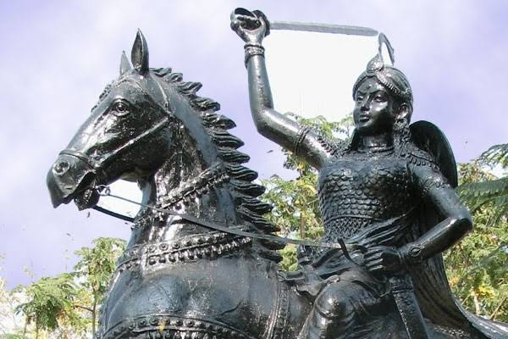

Since Ganapathideva had no sons, he performed the Putrika ceremony and formally designated Rudrama Devi as a son. For her male recognition, she was named Rudradeva. On the advice of the Prime Minister, Ganapathideva also nominated Rudramadevi to be his ‘male heir’.

She rose to power in her early teens when she was appointed co-regent and ruled alongside her father. She maintained the designation that was bestowed on her and ruled as a King. She wore male attire and maintained a similar demeanour. She was later married to Veerabhadra, prince of Nidadavolu with whom she had two female children.

**PANDYAN INVASION**:

In the first few years of the conjoined rule with her father, Rudramadevi saw the kingdom falling into utter chaos during the Pandya invasion. Jatavarman Sundara Pandyan I invaded their empire throwing it into disorder and confusion. The Kakateeyas along with their allies were disastrously defeated on the battlefield of Muttukur near Nelore. Although the invasion was eventually repelled and Ganapathi could ultimately turn back the tide of the invasion, he suffered the loss of territory and respect. Consequently, his control over feudatories and nobles were left in shaking grounds. The kingdom was now left in a weakened state.

Following the loss of prestige after the Pandya invasion, her father retired from the public sphere passing on the control to Rudrama. The powers now were vested in the hands of Rani Rudrama Devi. Scriptures suggest, she individually started ruling from 1261.

Around 1266 she lost both her father and her husband. After the demise of her father, Rudrama was finally coronated in 1269. She was now officially the Queen of the Empire. However, owing to her gender, several oppositions including that of her stepbrothers came her way. Harihara Dev and Murari Dev who refused to submit to a woman’s authority later rebelled against her.

**REGIME:**

Despite the antagonism she faced because of her gender, she rose up as one of the greatest warriors of her time. She drove back the Yedava King of Devagiri forcing him to finally sign a peace accord. She also introduced a new policy of recruiting people from the non-aristocratic background as commanders in the army as well as the administration. It was a radical step to take at that time. It is believed that she put forward such a policy to gain the trust of the commoners and thereby win new loyalists.

She also captured important forts like Renadu, Eruva Mulikinadu, and Satti.

Her accomplishments include the completion of the Warangal fort that her father had begun. It involved the addition of a second wall and a moat to the structure which was built to protect the city against future sieges.

History believes Rudrama Devi was one of the most outstanding queens of all times in Indian history. She played an active part in governing the country and maintained the best interest of her people. Despite the interruptions from neighbouring empires, her people remained contended under her rule. While her gender was no barrier for her, she faced the ill will of others owing to her gender.

**GLORY FROM OTHER LANDS:**

The Venetian traveller Marco Polo on his visit to the kingdom later spoke of her administrative qualities in high capacity. He appreciated her benign rule and greatness. He described her as a lady of discretion and appreciated her manners of justice and equity.

Through the annals of history, gender has time and again proven to be an ‘impediment’ and a tool of suppression. The thirteenth-century witnessed the rise of two such legendary queens who were downtrodden against their gender.

Razia Sultana, daughter of Iltutmish ascended the throne of the Delhi Sultanate in 1236 CE. In a sphere that was dominated by men, queens like Razia and Rudrama Devi fought their way to ultimately rule their kingdoms. However, the century is a testament to a sadder reality of suppression of these women despite being in the highest echelon. Razia’s reign lasted for four years. Minhaj-i Siraj writes that “She was endowed with all the admirable attributes and qualifications necessary for Kings. But her sex was her greatest disqualification.”

At a time when purdah formed the larger part of the Mughal customs and attire, Razia rose against the practice deeming it obstructive. Razia too discarded conventional female attire and dressed in qaba and kulah which were elements of dresses worm by men.

Attire and appearance become a common denominator in both these examples. Through the vicissitudes of history, the need for women to endow themselves with conventionally masculine traits and project themselves as men is symptomatic of a larger contradiction.

**Lakshmi Bai**

**BIRTH AND GROWTH:**

The future rani was born to a high-caste prominent Brahmin family in Benares (now Varanisi) in northern India on November 19, 1827. Formally named Manikarnika, she was called “Manu” by her parents. Her mother, Bhagirathi, died when she was 4. Under the care of her father, Moropant Tambe, her education included horsemanship, fencing and shooting. In 1842 she became the second wife of Gangadhar Rao Niwalkar, the childless raja of Jhansi, a principality in Bundelkhand.

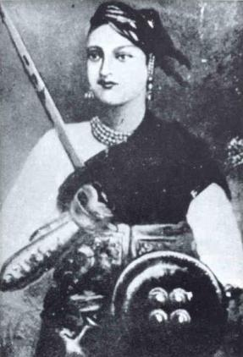

Renamed Lakshmi Bai, the young rani bore one son in 1851, but he died four months later. In 1853, following a serious illness, Gangadhar Rao adopted a distant cousin named Damodar Rao as his son—similarly, Gangadhar and the brother who had preceded him on the throne were adopted heirs. The adoption papers and a will naming the 5-year-old boy as Rao’s heir and the rani as regent were presented to a Major Ellis, who was serving as an assistant political agent at Jhansi on November 20, 1853. Gangadhar Rao died the following day. Ellis forwarded the information to his superior, Major John Malcolm, a Scottish soldier and the East India company representative in charge of the region, then controlled by Britain’s East India Company. Ellis was sympathetic to the rani’s claims, and even Malcolm, who did not support her regency, described the young widow in a letter to India’s Governor-General James Andrew Broun-Ramsay, 1st Marquess of Dalhousie, as “a woman highly respected and esteemed, and I believe fully capable of doing justice to such a charge.”

**FIGHT AGAINST BRITISH:**

Under Lord Dalhousie, the British government had adopted an aggressive policy of annexing Indian states. Charges of mismanagement often offered an excuse. Another justification, applied with increasing frequency after 1848, was the Doctrine of Lapse, which placed any sovereign Indian state as a vassal state under British rule through the East India Company. The British already exercised the right to recognize the monarchical succession in Indian states that were dependent upon them. As a corollary, Dalhousie claimed that if the adoption of an heir to the throne was not ratified by the government, the state would pass by “lapse” to the British.

In spite of the rani’s arguments for the legality of the adoption and Ellis’ statements on her behalf, Dalhousie refused to acknowledge Damodar Rao as Gangadhar Rao’s heir. The new British superintendent, Captain Alexander Skene, took control of Jhansi under the Doctrine of Lapse without opposition. The rani was allowed to keep the town palace as a personal residence and received an annual pension of 5,000 rupees, from which she was expected to pay her husband’s debts. Damodar Rao inherited the raja’s personal estate, but neither his kingdom nor his title.

**PROTECTING JHANSI**

On December 3, Lakshmi Bai submitted a letter contesting the Doctrine of Lapse with Ellis’ approval, but Malcolm did not forward it. She submitted a second on February 16, 1854. After a consultation with British counsel John Lang, during which she declared “*Mera Jhansi nahim dengee”* (I will not give up my Jhansi), she submitted yet another petition on April 22, and she continued to resubmit petitions until early 1856. All her appeals were rejected.

Meanwhile, discontent had been building among the Indian soldiers—known as sepoys—within the British East India Company’s army. The General Services Enlistment Act of 1856 required all recruits to go overseas if ordered, an act that would cause a Hindu to lose caste. Rumors spread that the cartridges for the newly issued Enfield rifles were greased with either cow or pig fat, regarded as abominations by the Hindu or Muslim sepoys who would tear them open with their teeth. Assurances that the cartridges were in fact greased with beeswax and vegetable oil were not as effective as rumors of a systematic British effort to undermine the sepoys’ faith and make it easier to convert them to Christianity. In Meerut on May 9, 1857, 85 sepoys who refused to use the Enfield cartridges were tried and put in irons. The next day three regiments stormed the jail, killed the officers and their families and marched on Delhi, 50 miles away. The incident started what became known as the [Indian Mutiny](https://www.historynet.com/indian-mutiny-of-1857-siege-of-delhi.htm).

Thousands of Indians outside the army had grievances of their own against British rule. Reforms against the practice of suttee (the act of a widow throwing herself onto her husband’s funeral pyre) and child marriage, permitting widows to remarry and allowing converts from Hinduism to inherit family property were seen as attacks on Hindu religious law. Land reform in Bengal had displaced many landholders. Violence spread through north and central India as leaders whose power had been threatened by the British took charge and transformed the mutiny into organized resistance.

**VIOLENCE AND WAR:**

On June 6, troops at Jhansi mutinied, shot their commanding officers and occupied the Star Fort, where the garrison’s treasury and magazine were stored. The city’s European populace took refuge in the fort under the direction of Captain Skene. The fort was well designed to withstand a siege: It included an internal water supply, but food was limited, and about half of the 66 Europeans were women and children. On June 8, Skene led the British out of the fort, but they were massacred. On June 12, the mutineers left Jhansi for Delhi.

Given Lakshmi Bai’s long-standing grievances against the government, the British were quick to blame the rising in Jhansi on her, but evidence of her involvement was thin. Skene’s deputies and personal servants reported that when the British asked the rani for assistance, she refused to have anything to do with the “British swine.” A Eurasian clerk’s wife who claimed to have escaped from the fort with her children reported that the rani had promised the British safe conduct. Her testimony has since been thoroughly debunked by prominent Indian history S.N. Sen in his thoughtful study titled “1857,” but the idea that she had betrayed the community inflamed British imaginations.

**MAJOR WALTER**

Lakshmi Bai herself sent an account of the massacre to Major Walter Erskine, the commissioner at Sagar and Narbudda, on June 12:

*The Govt. forces, stationed at Jhansi, thro’ their faithless, cruelty, and violence, killed all the European Civil and Military officers, the clerks and all their families and the Ranee not being able to assist them for want of Guns, and soldiers as she had only 100 or 50 people engaged in guarding her house she could render them no aid, which she very much regrets. That they, the mutineers, afterwards behaved with much violence against herself and her servants, and extorted a great deal of money from her….That her dependence was entirely on the British authorities who met with such a misfortune the Sepoys knowing her to be quite helpless sent me messages […]to the effect that if she, at all hesitated to comply with their requests, they would blow up her palace with guns. Taking into consideration her position she was obliged to consent to all the requests made and put up with a great deal of annoyance, and had to pay large sums in property as well as cash to save her life and honour. Knowing that no British officers had been spared in the whole District, she was, in consideration of the welfare and protection of the people, and the District, induced to address Perwannahs to all the Govt. subordinate Agency in the shape of Police, etc. to remain at their posts and perform their duties as usual, she is in continual dread of her life and that of the inhabitants. It was proper that the report of all this should have been made immediately, but the disaffected allowed her no opportunity for so doing. As they have this day proceeded towards Delhi, she loses no time in writing.*

In a subsequent letter, the rani reported there was anarchy and asked for orders from the British. Erskine forwarded both letters to Calcutta with a note saying her account agreed with what he knew from other sources. He authorized the rani to manage the district until he could send soldiers to restore order.

Faced with attacks by both neighboring principalities and a distant claimant to the throne of Jhansi, Lakshmi Bai recruited an army, strengthened the city’s defenses and formed alliances with the rebel rajas of neighboring Banpur and Shargarh. Her new recruits included mutineers from the Jhansi garrison.

The positive assessment of local British officials was not enough to overcome the British belief in Calcutta that Lakshmi Bai was responsible for the mutiny and the massacre. Her subsequent efforts to defend Jhansi confirmed their beliefs. In January 1858, Major General Sir Hugh Rose marched toward the city. As late as February, the rani told her advisers that she would return the district to the British when they arrived.

**SEIGE IN JHANSI**

On March 25, Rose laid siege to Jhansi. Threatened with execution if captured by the British, Lakshmi Bai resisted. In spite of a vigorous defense, by March 30, most of the rani’s guns had been disabled and the fort’s walls breached. On April 3, the British broke into the city, took the palace and stormed the fort.

The night before the final assault, Lakshmi Bai lashed her 10-year-old adopted son to her back and, with four followers, escaped from the fortress. Her father was less fortunate. He was captured and summarily hanged by the British, who sacked Jhansi for the next three days. After riding some 93 miles in 24 hours, Lakshmi Bai and her small retinue reached the fortress of Kalpi, where they joined three resistance leaders who had become infamous in British eyes for the atrocity at Cawnpore: Nana Sahib, Rao Sahib and Tatia Tope. The rebel army met the British at Koonch on May 6 but was forced to retreat to Kalpi, where it was defeated again on May 22-23.

**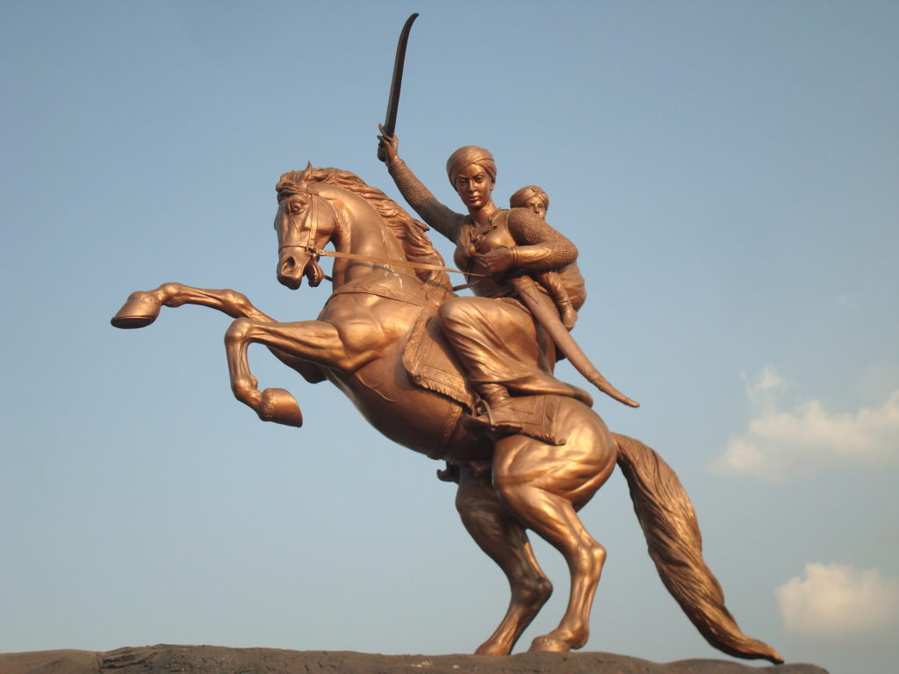  
WAR AT GWALIOR**

On May 30, the retreating rebels reached Gwalior, which controlled both India’s major thoroughfare, the integral Grand Trunk Road, and the telegraph lines between Agra and Bombay. Jayaji Rao Scindhia, the maharaja (grand ruler) of Gwalior, who had remained loyal to the British, tried to stop the insurgents, but his troops went over to their side on June 1, forcing him to flee to Agra.

On June 16, Rose’s forces closed in on Gwalior. At the request of the other rebel leaders, Lakshmi Bai led what remained of her Jhansi contingent out to stop them. On the second day of the fighting at Kotah-ki-Serai, the rani, dressed in male attire, was shot from her horse and killed. Gwalior fell soon after, and organized resistance collapsed. Resistance leaders Rao Sahib and Tatia Tope continued to lead guerrilla attacks against the British until they were captured and executed. Nana Sahib disappeared and became a source of legend.

**Jezebel of India**

British newspapers proclaimed Lakshmi Bai the “Jezebel of India,” but Sir Hugh Rose compared his fallen adversary to Joan of Arc. Reporting her death to William Augustus, Duke of Cumberland, he said: “The Rani is remarkable for her bravery, cleverness, and perseverance; her generosity to her subordinates was unbounded. These qualities, combined with her rank, rendered her the most dangerous of all the rebel leaders.”

**Chhatrapati Sambhaji Maharaj**

**BIRTH:**

Chhatrapati Sambhaji Maharaj was the eldest son of Chhatrapati Shivaji Maharaj - the great Maratha warrior king. Shivaji Maharaj belonged to the Bhonsle clan and was born on 19th February 1627. Shivaji Maharaj built the Hindawi Swaraj - the Self-rule of Indians as against that of the Mughals who identified themselves as descendants from Tamerlane of Mongolia and also of Turcik - Central Asian (Chagtai) bloodline.

Chhatrapati Shivaji Maharaj died on 3rd April 1680 but in his lifetime, he laid the foundation for the genesis of the Maratha empire - a solid bulwark against invaders. His son Sambhaji Maharaj had a huge task cut out before him - to defend the Maratha empire against the might of the Mughals in Delhi who were later subdued and decimated by the Maratha armies) and to carry on the vision and policies of Shivaji Maharaj.

**RISE OF MARATHA EMPIRE:**

Sambhaji Maharaj had witnessed the lengths the Mughal emperor Aurangzeb would go to annihilate any challenge to the Mughal might. Aurangzeb had succeeded his father Shah Jahan by treachery and fratricide of his three brothers. After killing his brothers in cold blood and imprisoning the father - the builder of the Taj Mahal - he is said to have killed brother Dara Shikoh's two sons and forced his widows to marry him. He began forcing conversions of the local Indians to Islam and imposed the Jizya tax on non-Muslims.

After Shivaji Maharaj's death, Sambhaji had several challenges on hand: the Mughals in the north, and other neighbouring powers such as the Siddis, Mysore and the Portuguese in Goa.

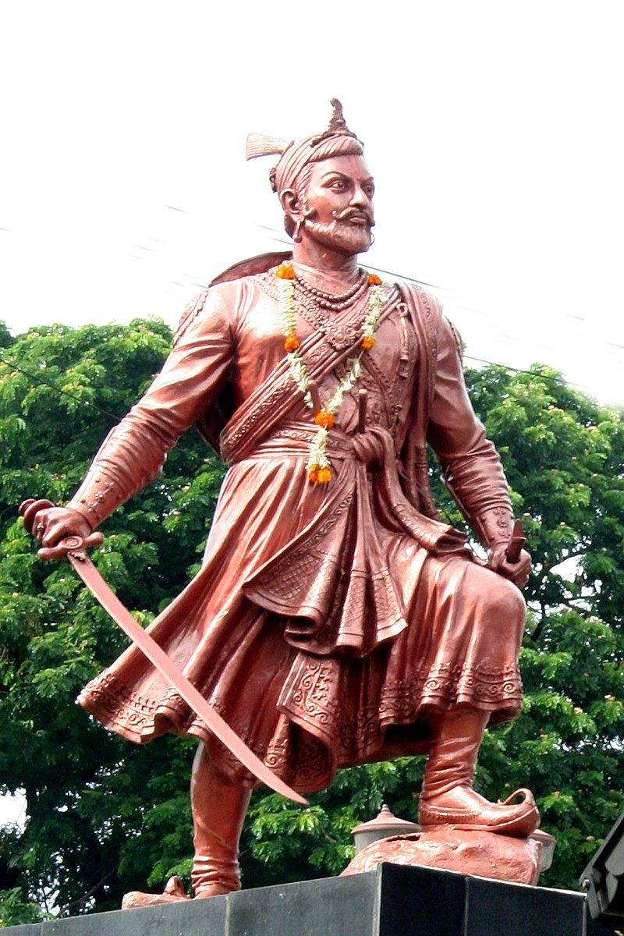

**ATTACK FROM MUGHALS**

In 1681, Aurangzeb's fourth son Akbar reached Deccan (variation for Dakshin or the South) and tried to consolidate forces against his father's rule in Delhi.

To quell this rebellion and to try to finish off the Maratha empire, Aurangzeb left Delhi with 4-5 lakh soldiers and headed to Khirki - what is today's Aurangabad in Maharashtra.

In 1682, Aurangzeb tried attacking the Maratha Empire from all directions. He intended to use the Mughal numerical superiority to his advantage. Sambhaji had prepared well for the invasions and the Maratha forces promptly engaged the numerically strong Mughal army in several small battles using guerilla warfare tactics.

Aurangzeb's son Akbar had approached Sambhaji Raje for help. Shambhu Raje had promised him assistance to fight Aurangzeb. But Akbar soon fled to Persia.

Meanwhile, Sambhaji Maharaj continued to fight alongside his generals in all battles and wars at hand. Aurangzeb had seen Sambahji Raje in 1966 as well when the feisty Shambhu Raje had accompanied his brave father to the Mughal court in Agra.

**DECIEVEMENT:**

Aurangzeb had invited the two for his birthday celebrations at the Darbar but imprisoned them by deceit. For almost three months, the father-son duo was held under house arrest.  The maturity of the young lad was seen in the way he handled the time he was near Mathura secretly on his way back to Maharashtra) disguised as a Brahmin priest's child and was accosted by Mughal soldiers who suspected that he was Sambhaji the young Maratha prince.

"Eat in the same plate, if you two are really father and son from a priestly family," the soldiers ordered. The accompanying Brahmin priest wondered how the young lad will pull it off. Will his princely stature become a prestige issue and blow the lid over their true identities? No such thing happened. The boy acted as though the accompanying priest was indeed his father and broke bread with him without betraying the truth. Aurangzeb regretted this failure on his own part till his dying day.

After Shivaji Maharaj's death, Sambhaji Raje succeeded him, details of which I am not getting into here. He carried on the good governance of his father. Chhatrapati Sambhaji Maharaj was loved and revered by his subjects.

**GLORY:**

British origin historian Dennis Kincaid writes, "He (Sambhaji) was ordered by the Emperor to embrace Islam. He refused and was made to run the gauntlet of the whole Imperial army. Tattered and bleeding he was brought before the Emperor and repeated his refusal. His tongue was torn and again the question was put. He called for writing material and wrote 'No, never!' So then he was put to death by torture". He was beheaded and his head was mounted on a pike that was then displayed to the public so as to demoralise them.

"His sacrifice has earned Chhatrapati Sambhaji Maharaj the spot of reverence in the hearts of all. Aurangzeb managed to capture him by deceit on 1 February 1689. Sambhaji Maharaj was tortured for days and killed in the most heinous fashion and died on 11 March 1689. He showed exemplary courage in facing death only to protect three of the things he held most dear in life... Dev, Desh, and Dharma (God, Country, and Religion).  That is the reason why he is revered in Maharashtra. People realise and appreciate the fact that he did not fall prey to Aurangzeb's tactics, and chose to embrace death rather than betray the cause he stood for," an author of several books chronicling the Maratha empire's era said. Not wishing to be named here, this author is an authority on Maratha history and is all set to publish his latest book on the life of Sambhaji Maharaj soon.

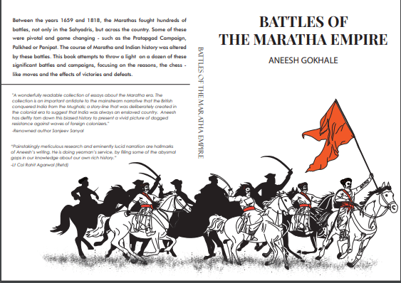

Meanwhile, another celebrated author of Maratha history - Aneesh Gokhale (his book "Battles of Maratha Empire" among several others he has penned) says, "Chhatrapati Sambhaji held off a grand Mughal army numbering 5,00,000 souls led by Aurangzeb himself for nearly a decade. The Mughals' aim of making an example out of him by capturing Chhatrapati Sambhaji, and torturing him to death backfired as the Marathas were galvanised to fight even harder. In life, Chhatrapati Sambhaji led a decade long struggle against the Mughals, in death he inspired them to fight for two decades more.

**Bajirao-I**

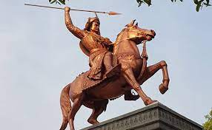

One of the greatest warriors to have ever lived, Bajirao-I, was a capable general of the Maratha Empire who served as the Peshwa to Shahu. He is credited with expanding the Maratha Empire in India, and is said to have never lost a battle in his military career spanning 20 years. Today, August 18, we remember him on his 320th birth anniversary by taking a look at some interesting facts about him.

**ORIGIN:**

Bajirao-I was born on August 18, 1700 in Dubere, Sinnar, Maratha Empire (present-day Nashik district in Maharashtra) to Balaji Vishwanath and Radhabai Barve, and had three younger siblings, a brother and two sisters. He was inspired by the life stories of Shivaji, Sambhaji, Ramchandra Pant Amatya and Santaji Ghorpade.

Some of the interesting facts about him are as follows:

Bajirao-I was trained as a diplomat and as a warrior under his father Balaji Vishwanath, and his formal education included reading, writing and learning Sanskrit.

 He would often accompany his father on military campaigns, and was with the latter when he was imprisoned by Damaji Thorat.

After his father Balaji Vishwanath died, Bajirao-I was appointed as the Peshwa when he was only 20-years of age.

**BATTLES FOUGHT:**

Bajirao-I helped Nizam-ul-Mulk Asaf Jah I win the Battle of Sakhar-kheda in October 1724, and was awarded with a robe, a mansabdari of 7,000, an elephant, and a jewel.

He fought against Nizam at the Battle of Palkhed on February 25, 1728 and defeated him, earning Shahu the recognition as the Chhatrapati as well as the Maratha right to collect taxes in the Deccan.

Bajirao-I had two wives, with the first being Kashibai, who bore him three sons, namely Balaji Baji Rao, Raghunath Rao and Janardhan Rao. His second wife was Mastani and she bore him a son named Krishna Rao, who later came to be known as Shamsher Bahadur.

Bajirao had moved his base of operations from Saswad to Pune in 1728, and also started construction of Shaniwar Wada in 1730. The Shaniwar Wada was the seat of the Peshwas of the Maratha Empire until 1818.

**DEATH:**

On April 23, 1740, Bajirao-I died after suffering from a fever for five days while he was in a camp in Raverkhedi. He was cremated on the same day, and his son Balaji Baji Rao ordered a memorial to be built there.

Bajirao-I was well known for his battle tactics, and his skill in rapid troop movement which helped him win many battles. British Field Marshal Bernard Montgomery, in his book A Concise History of Warfare, termed Bajirao’s success at the Battle of Palkhed as being ‘a masterpiece of strategic mobility’.

**Narasimha Reddy**

Telugu soil has seen some brave freedom fighters who have given enough push in The Indian Independence Struggle. One such brave heart who was one of the early freedom fighters was the fierce Uyyalawada Narasimha Reddy. In the early colonial rule, British rulers oppressed the Indian rulers in their expansion mode. They fleeced the local rulers and chieftains, to forcefully collect the taxes from people.

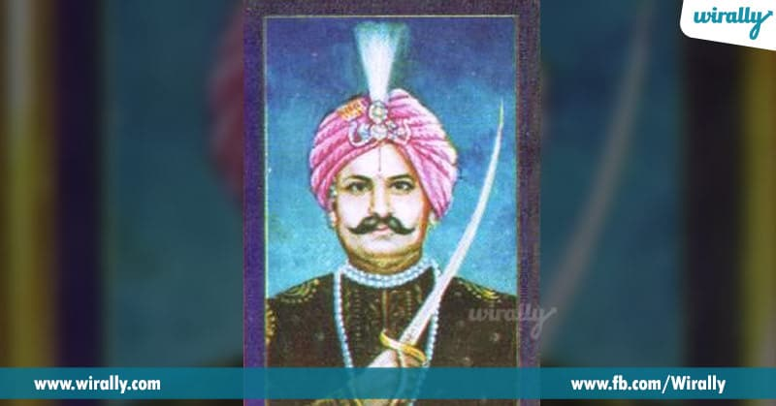

**BIRTH AND GROWTH:**

One such ruler was Uyyalawada Narasimha Reddy of Rayalaseema Region. He was born around early 1800’s to the local chieftains’ (Zamindari) family in the present Kurnool district on the banks of Kundi River. Uyyalawada Narasimha Reddy is one of the earliest freedom fighters in India. Reddy, who had 66 villages under his control and an army of 2000 men, could not contain the atrocities committed by the corrupt officials of EIC (East India Company) and the suffering his people had to go through under their colonization.

**FIGHT AGAINST BRITISH:**

The Rayalaseema region was transferred to the British by the Nizam and Reddy refused pay taxes directly to the British. On 10 June 1846 he raided the treasury at Koilakuntla and marched towards Kambham, Andhra Pradesh (Prakasam District). On the way, at Rudravaram he killed the forest ranger. This being a serious matter, the then Collector Thomas Monroe issued orders to arrest him. The EIC put a price on his head Rs. 5000 and Rs. 10,000 for his head.

Reddy, with his army mounted a serious attack on the British forces camped at Giddaluru on 23 July 1846 and defeated them. Unable to capture him, the British deceptively imprisoned his family at Kadapa. Narasimha Reddy moved to Nallamalaforest to save his family butthe British forces were tipped off by someone about the hideout of Mr. Reddy. To avoid being caught by the British in the Nallamala area, Narasimha Reddy returned to Koilkuntla area and hid in Jagannatha Konda.

**DOWNFALL:**

Unable to be at large for a long period, Reddy was caught as the army moved in upon a tip-off and arrested him and his followers at mid night of 6 October 1846. The EIC put heavy fetters on him and paraded him right in the streets of Koilkuntlabefore his people with blood-stained clothes so that it would be a warning to them. Around 112 of his followers were arrested and convicted for 5 to 14 years and some of them were jailed in Andaman. The special commissioner of Kadapa conducted the trial and Narasimha Reddy was charged with revolt, murder and being a dacoit and was convicted on all charges. He was publicly hanged on 22nd February 1847, on the banks of nearby river in the presence of Collector Kokcrane. His head was kept on the fort wall in public view for 30 years from 1847 to 1877 to instill fear in the people so that another rebellion won’t be tried by others against the British.

Another blot in the British India history. A patriot was dubbed as a murderer and robber and, at last, was mercilessly killed by the early British rulers.His revolt in India against the British occupation was 10 years earlier than India’s First War of Independence of 1857 also known as Sepoy Mutiny of 1857. The vestiges of the early events are well frozen in the ruins of the fort at Kotthakota, near Giddalur. Plans are afoot to erect a statue in honour of Reddy and the government also has plans to include his brave story in the school text books.